**RECKLESS DRIVING DETECTION SYSTEM**

**GROUP MEMBERS:** GUFRAN BHATTI (64386), SARIM AMIR (63686), ABDUL BARI (10233)

**CONTEXT REASONING:**

**DECISION TREE (80:20 Train test split ratio):**

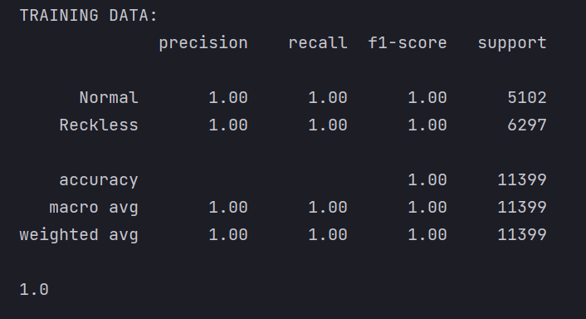

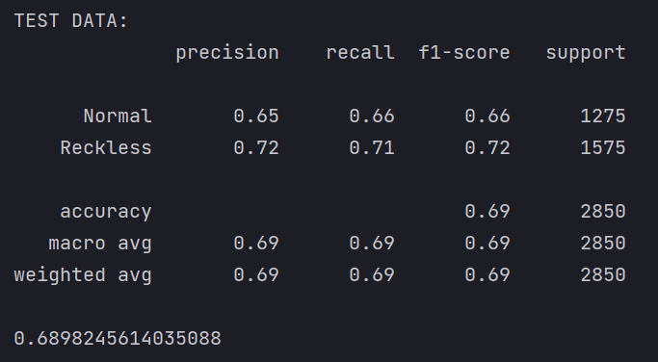

**DECISION TREE (70:30 Train test split ratio):**

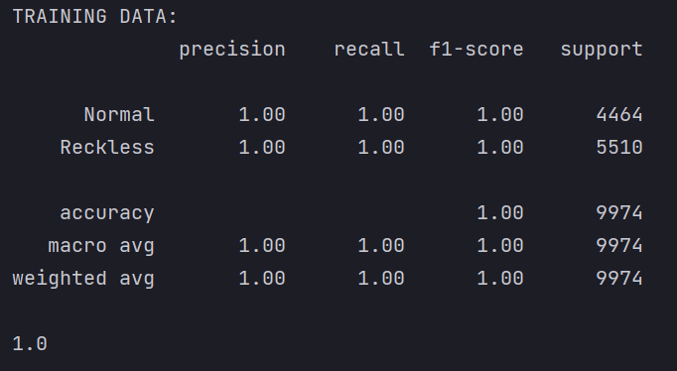

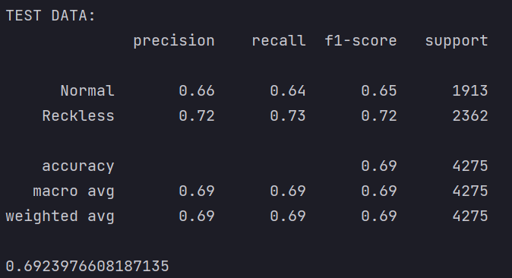

**DECISION TREE (90:10 Train test split ratio):**

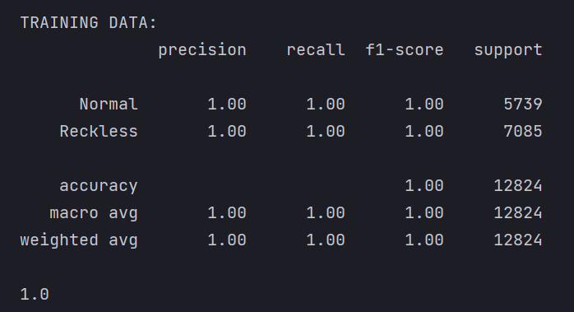

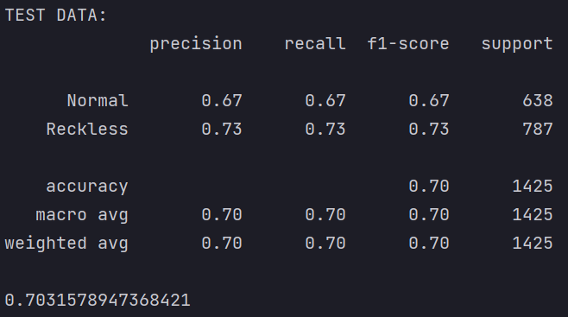

**DECISION TREE IMPLEMENTED WITH CROSS-VALIDATION WITH K=4:**

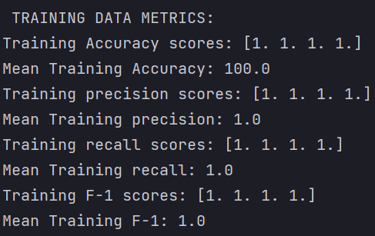

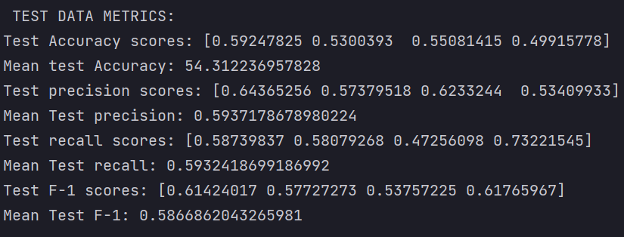

**RANDOM FOREST (80:20 train test ratios):**

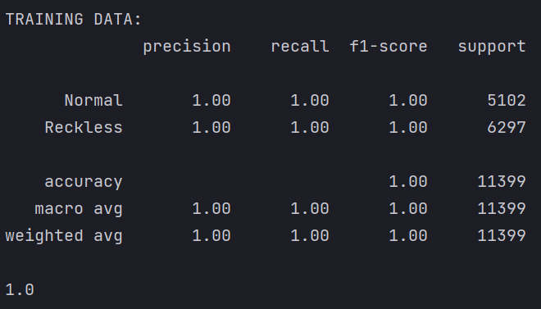

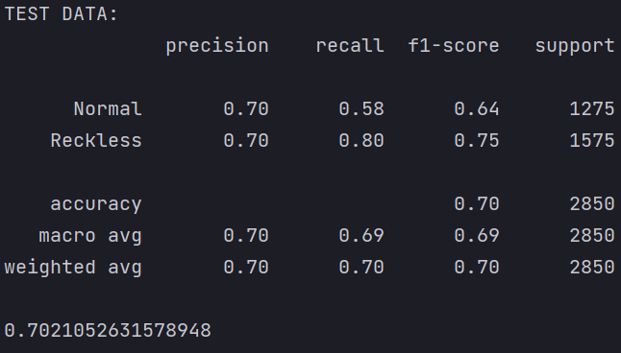

**RANDOM FOREST (70:30 train test ratios):**

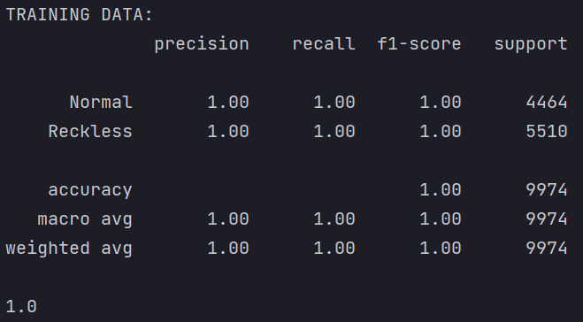

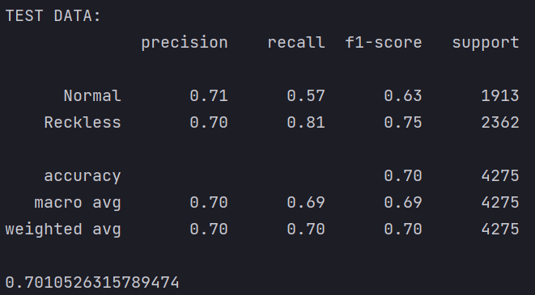

**RANDOM FOREST (90:10 train test ratios):**

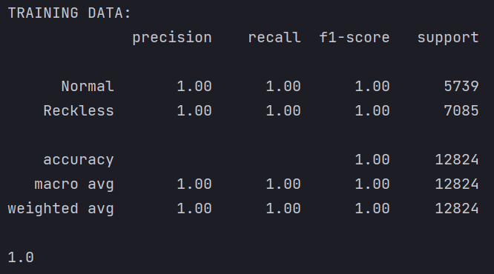

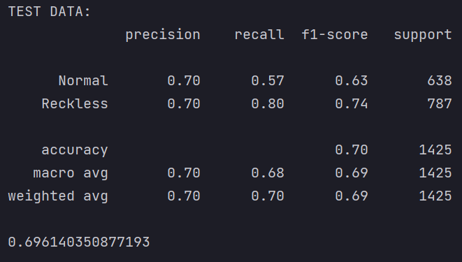

**RANDOM FOREST with cross-validation with k = 4**

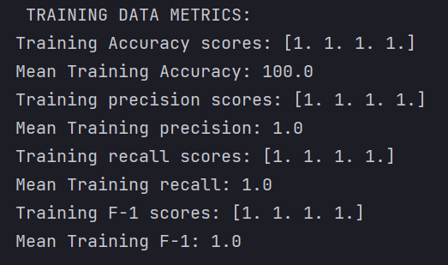

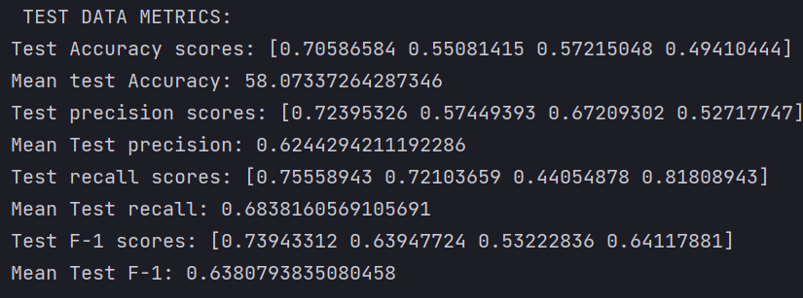

**DNN with 3 layers, epoch =100,batch_size = 128, validation_split=0.1,loss=’binary_crossentropy,callbacks = earlystopping if validation accuracy starts decreasing**

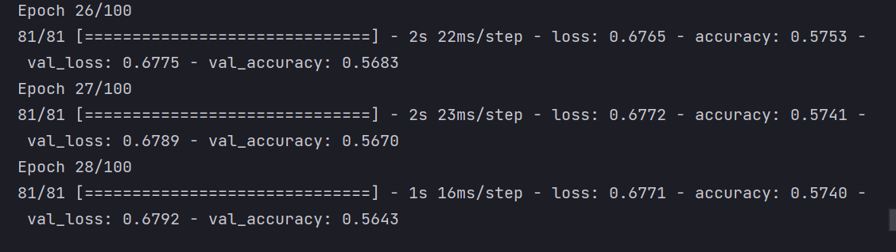

Stopped on epoch 28 because validation accuracy starts decreasing as you can see the validation accuracy in epoch 27 is greater than the validation accuracy in epoch 28.

**Bi-LSTM having 4 layers with epoch = 100, batch_size = 64, loss=’binary_crossentropy,callbacks = earlystopping if loss starts increasing**

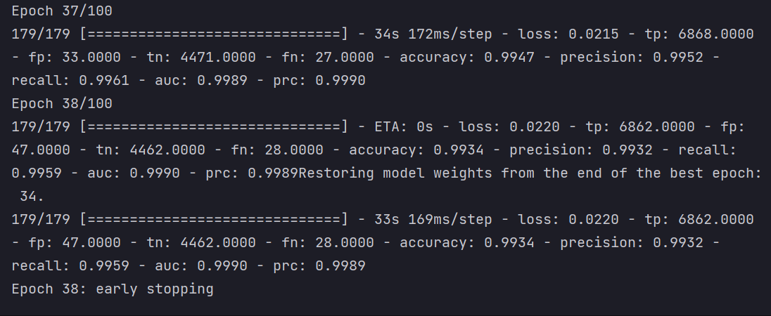

Stopped on epoch 38 because the loss starts increasing as you can see loss in epoch 38 is greater than the loss in epoch 37.